# WorkFlows

## Build and push Docker images

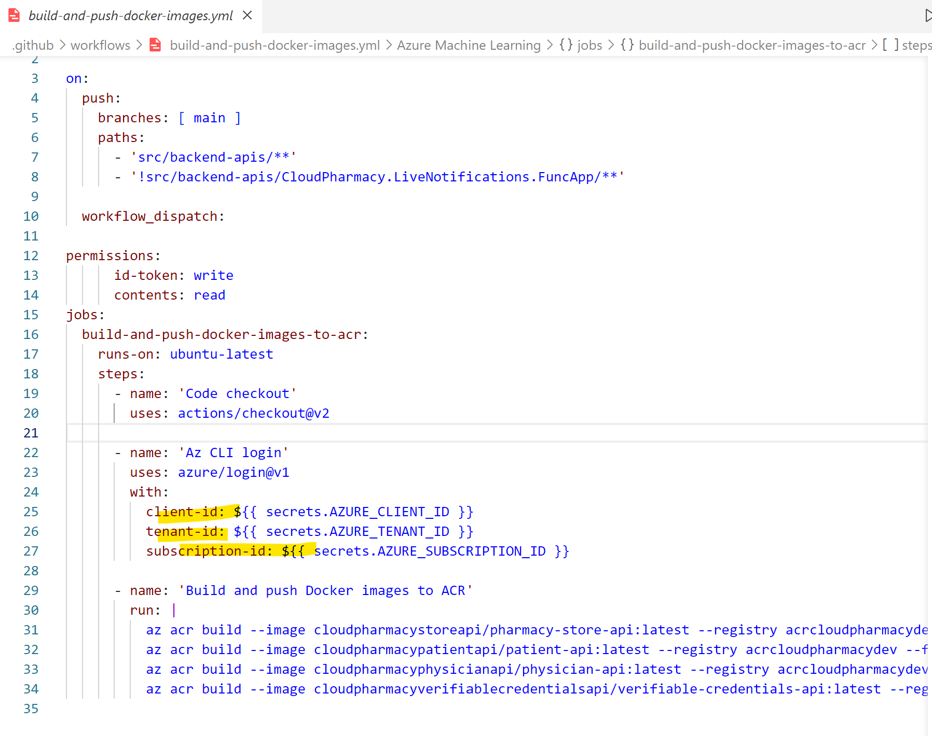

### Create PharmacyAppGitHubActions ServicePrinciple

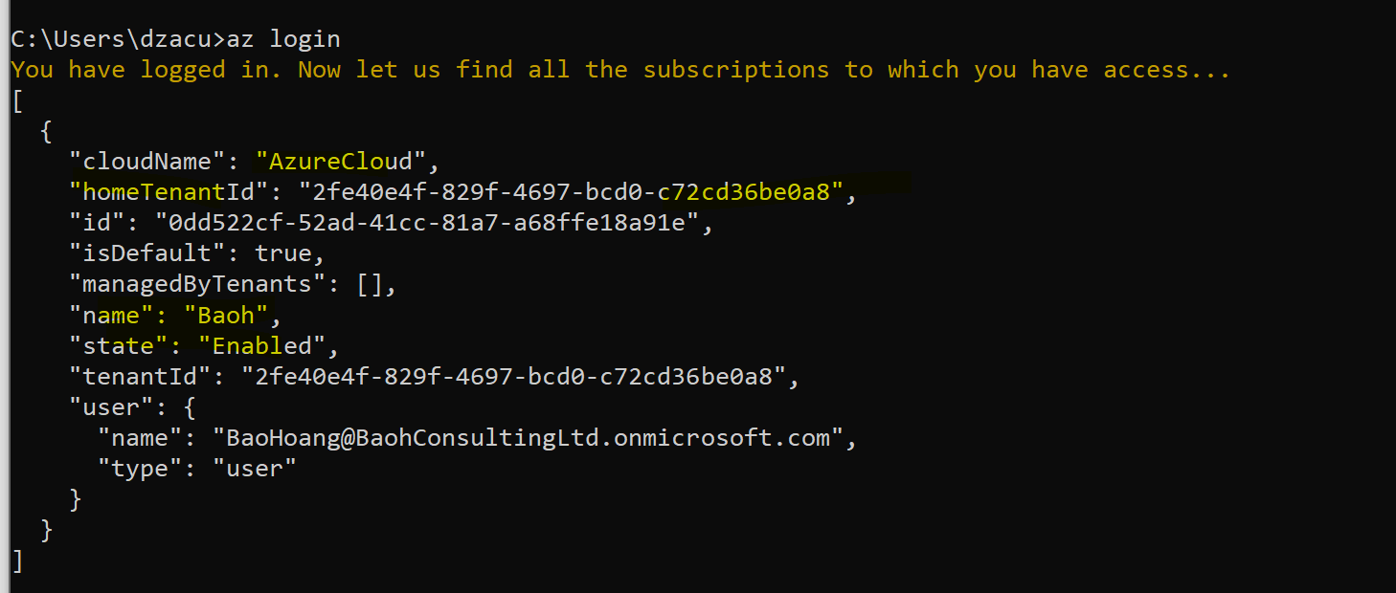

#### Create PharmacyAppGitHubActions service principle

az ad app create --display-name "PharmacyAppGitHubActions" **--- creating an Azure AD app**

az ad sp create --id 66a555cd-7bbb-46b6-a347-b5b314f2f42a **---- creating the service principle**

az role assignment create --assignee 66a555cd-7bbb-46b6-a347-b5b314f2f42a --role Contributor --scope /subscriptions/0dd522cf-52ad-41cc-81a7-a68ffe18a91e/resourceGroups/rg-cloud-pharamcy-dev **---- assign role & scope**

az ad app credential reset --id 66a555cd-7bbb-46b6-a347-b5b314f2f42a –-append **----- create a secret**

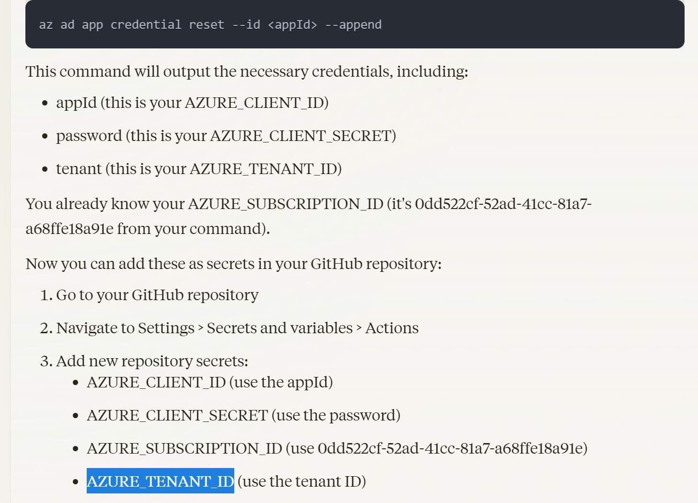

### Az Cli Login

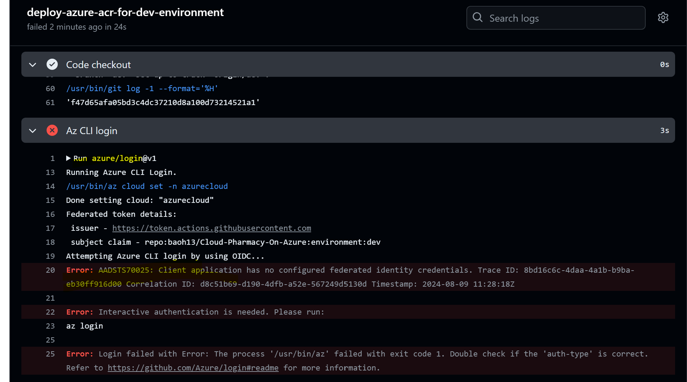

Estabish a federated trust with Github actinos

az ad app federated-credential create --id 66a555cd-7bbb-46b6-a347-b5b314f2f42a --parameters "{\"name\":\"GitHubActions\",\"issuer\":\"https://token.actions.githubusercontent.com\",\"subject\":\"repo:baoh13/Cloud-Pharmacy-On-Azure:environment:dev\",\"audiences\":[\"api://AzureADTokenExchange\"]}"

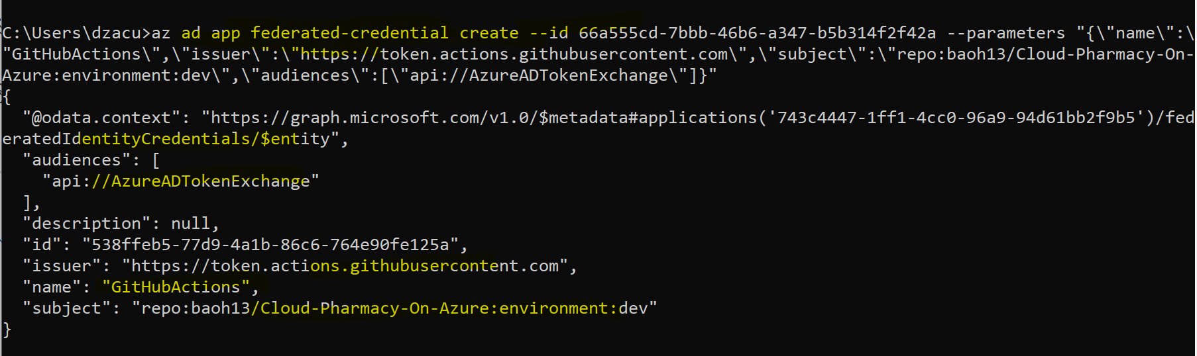

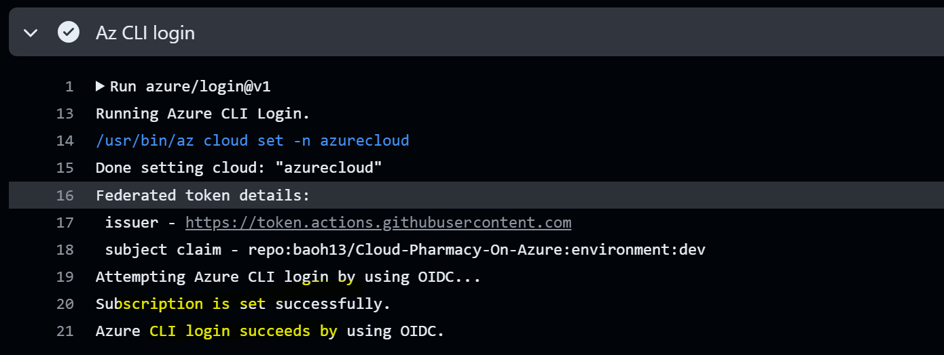

### Register Microsoft.ContainerRegistry

az provider register --namespace Microsoft.ContainerRegistry